# Brown Elementary School

## 2023-2024 5th GRADE SUPPLY LIST

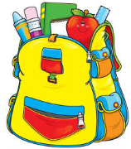

* 5 composition notebook, *labeled with student’s name*
* 5 pocket folders
* 1 pkg of white 3x5 index cards
* 1 box of tissue
* 2 containers of disinfecting wipes
* 3 glue sticks
* 1 **small box of 24** crayons (**NO MORE THAN 24 please!**)
* 6 **EXPO** markers
* 1 pkg. sharpened Ticonderoga Pencils
* 3 highlighters (yellow, pink, green)
* 2 black sharpies
* 1 pkg sticky notes
* 1 pair of scissors
* 1 set colored markers
* 1 pack of colored pencils
* 1 box of crayons (24)
* 1 pack of correcting pens
* $20 class fee
* 1 ream of copy paper

Note: You will receive a teacher specific supply list (only few other items) and a welcome letter from your teacher in August when teachers are announced in Infinite Campus.

Thank you,

5th Grade Teachers